TINY THUNDERBIRD PLUG-IN USER GUIDE

Starting with Thunderbird plug-in, first of all you need to set the configuration settings of Tiny ERP.

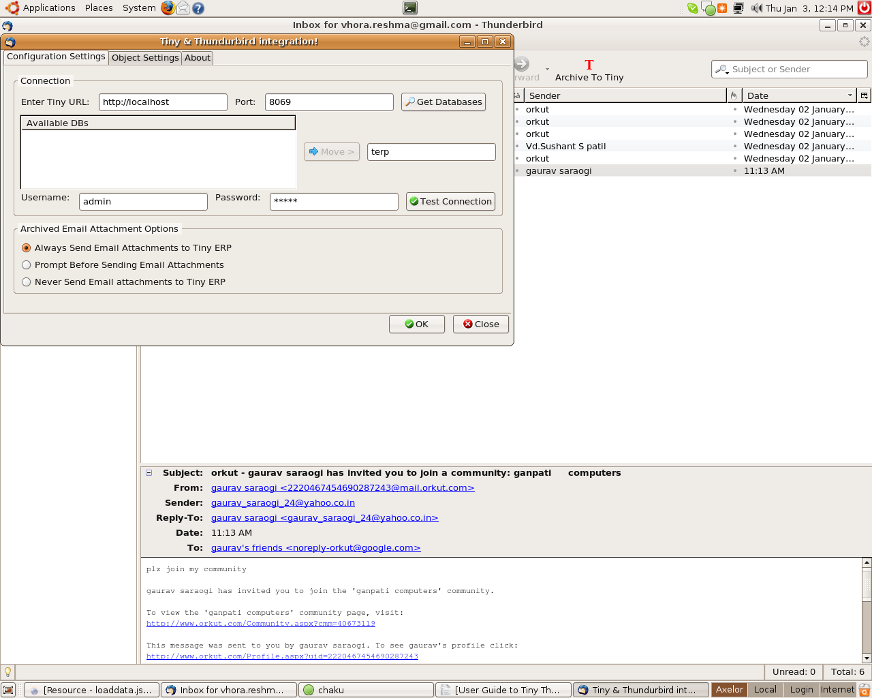
How to set the configuration of Tiny ERP in thunderbird ?
- From Menu Bar, Open Tools -> Tiny Plugin
- In “Configuration Settings” tab, default values for the server path, port, database name, username and password will be set for the localhost.
- Click on “Get Databases” and the list box “Available DB's” will get filled up with the available list of database in Tiny ERP.
(Be sure Tiny ERP Server is running)
- Click on “Move” to set the database you want to use for storing the Thunderbird E-mails.

- Click on “Test Connection” to check whether the username and password you have entered is correct or not.
- Select one of the radio button to set the Attachment saving option to Tiny ERP while Archiving E-Mails from Thunderbird.

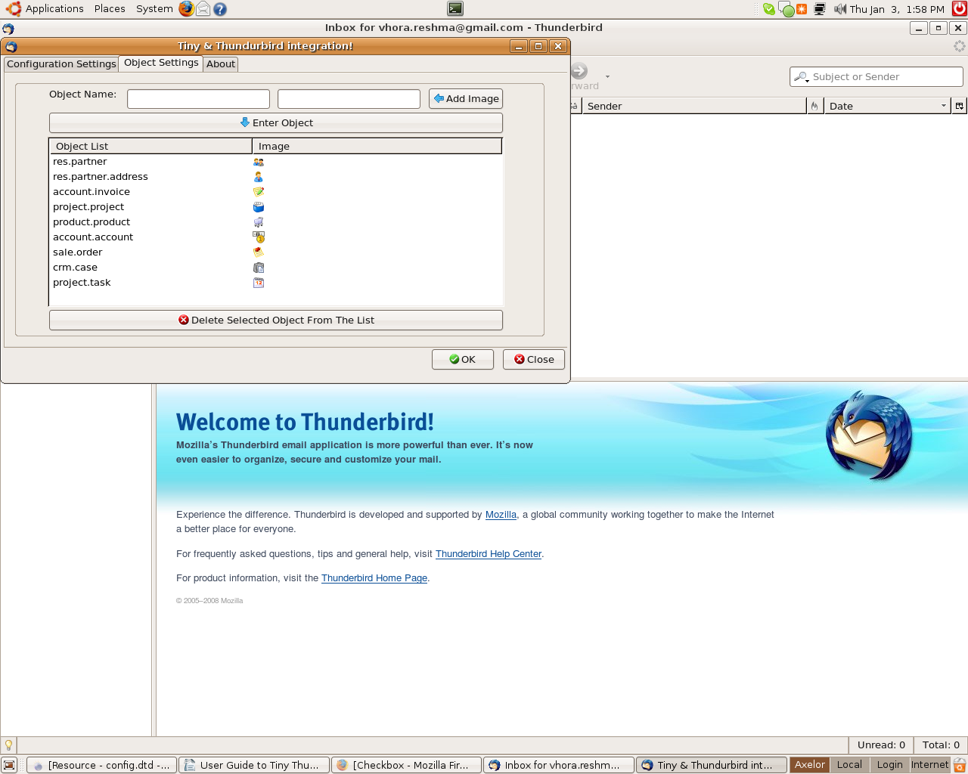
- In “Object Settings” tab, default list of objects will be set.
- While adding a new object write the object name that exist in Tiny ERP and than click on “Add Image” to select the image.
(For better visualization use small size image (16 x 16 or 32 x 32))
- Click on “Enter Object” to set that object and image in the list of objects.
- For deleting the existing object, select one of the object from the list of objects and click on “Delete Selected Object From The List”.

How to use Thunderbird plug-in to archive your emails to Tiny ERP ?

1. Searching the records from Tiny ERP
For archiving your selected email to Tiny ERP, select one of the email from the list of emails and click on the “Archive To Tiny”, a new window “Archive To Tiny!” will open.

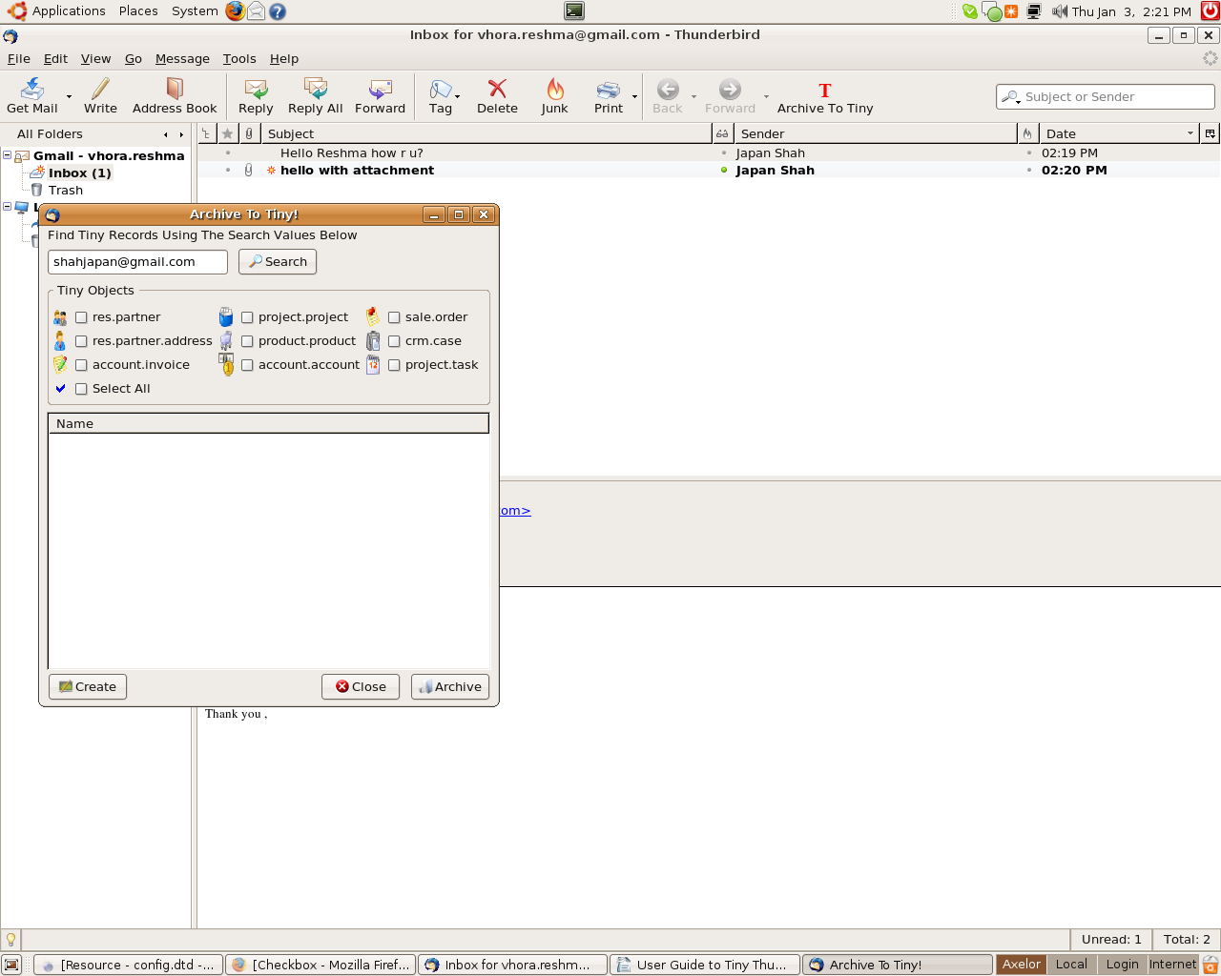
In this new window the text box contains the email id of the sender of the email. Now the no. of checkbox depends on the list of objects present in the Configuration settings. Now select one of the checkbox and click on “Search” and this will try to search in Tiny ERP for the value in the text box for a particular object. This will try to search for the name field if any in all the objects other than “res.partner.address”. Rather it will search for both email and name in “res.partner.address” and will fill the searched values in the list box.

Here in the below shown figure it shows the list of records found in Tiny ERP on the basis of the value in the text box. We provide multi functional search feature by selecting multiple checkbox. To identify the records according to the object we provide the image according to the checkbox image which is basically the image in the configuration settings.

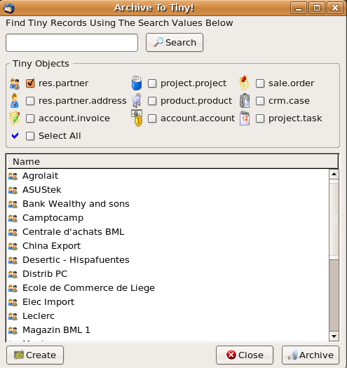

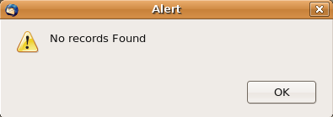

If while searching the search engine fails to get the records it will show an alert window as shown below.

2. Archiving email to the Selected Record of Tiny ERP
For archiving email to selected record of Tiny ERP, select one of the record from the list of the records and click on “Archive”.
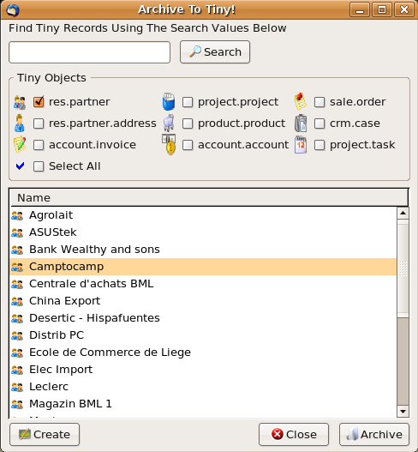

If the email does not contain the attachment, the below shown alert window will appear.
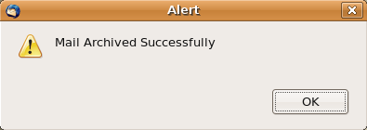

3. Creating a Contact to archive email to Tiny ERP
If while searching it fails to show the records than you can create your own contact in Tiny ERP with which you can archive your email.

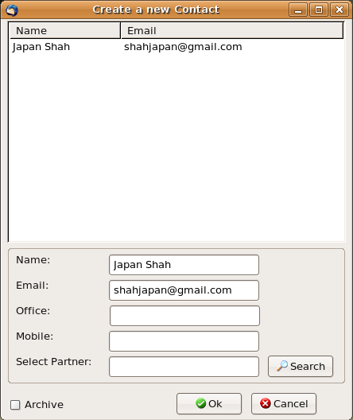

In the above window the list box contains the name and email of the sender of the email and even the text box contains the same. The other text box contains the office and mobile phone no. which are not compulsory. But the text box select partner which is read only, has to be filled compulsorily. To fill the partner value search for the partners existing in Tiny ERP or you can create a new partner.

While you click on “Search” a new window will appear where you can search for the existing partners in Tiny ERP.

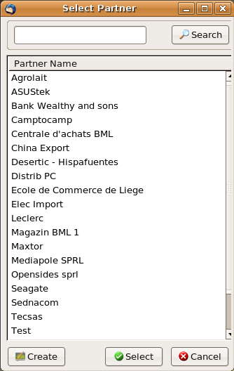

If the partner with which you want to archive the email does not exist you can create a new partner. For that click on “Create” and a new window will appear where you need to write the name of the partner and click “Ok”.

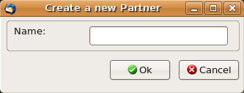

While you click on “Ok” and if the partner with the same name exist in Tiny ERP than it will show an alert window that the “Partner Already Exist”.

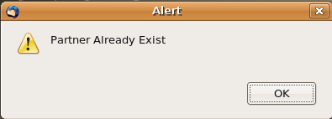

If a new partner is created successfully than the below shown alert window will appear.

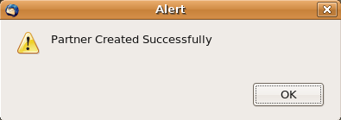

Now after creating a new partner select the partner in the list box and click on “Select” to select the partner for which you want to create a contact in Tiny ERP.

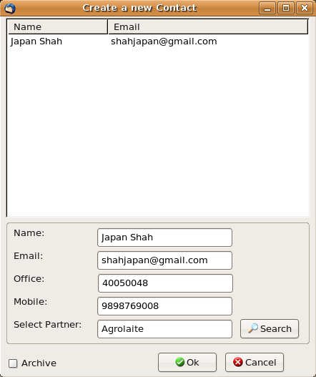

If you just want to create the contact and dont want to archive the email than without selecting the “Archive” checkbox just click “Ok”. On successfull creation of the new contact for the selected partner a new alert window will appear as shown below.

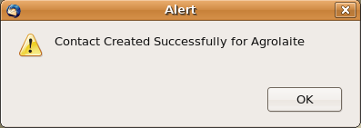

And if you want to create the contact with archiving the email too than check the checkbox “Archive” and than click “Ok”. On successfull creation of contact and archiving of email the below shown alert window will appear.

4. Archiving emails with attachment to Tiny ERP
While you select the email that contains attachment for archiving it to Tiny ERP, the below shown window will appear. And than click on “Ok”.

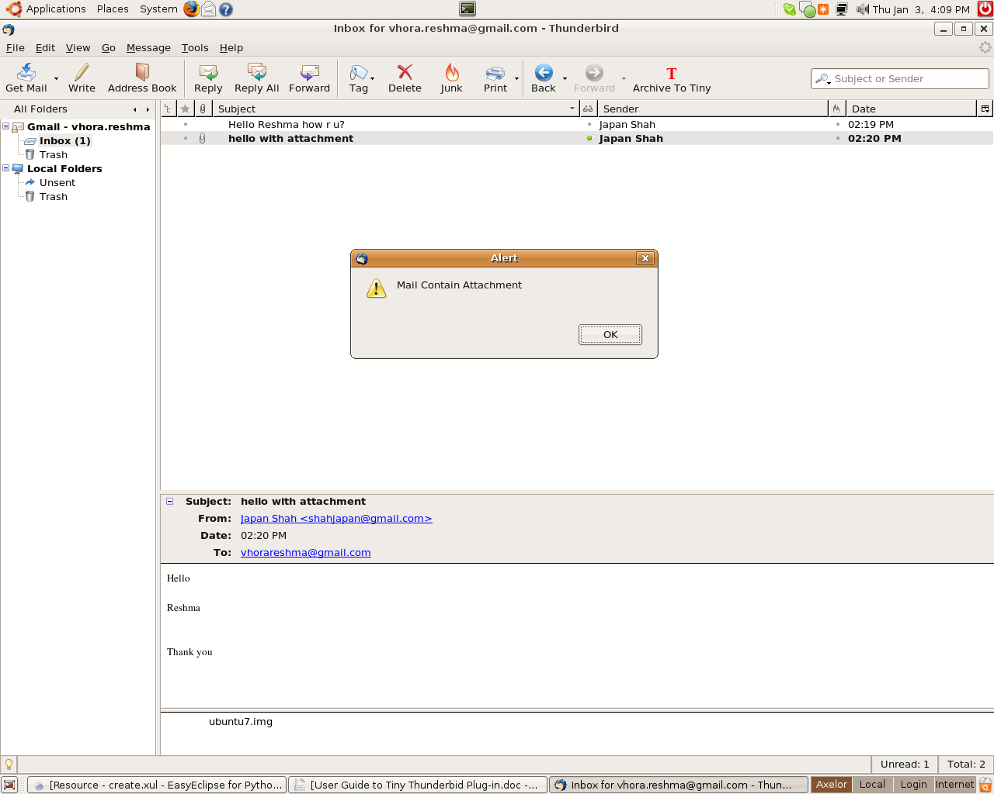

When you will click on “Ok” the process of reading the attachment will be completed and than the “Archive to Tiny” window will appear and than the whole process will be the same as we have explained before.

Enjoy Archiving the Thunderbird Email to Tiny ERP

